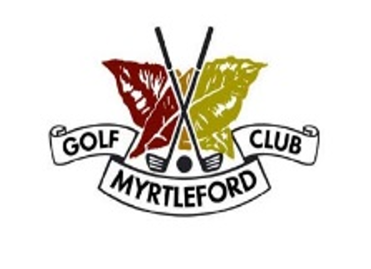
MYRTLEFORD GOLF CLUB INC.
2023 TOURNAMENT
Torneo di Golf Annuale in conjunction with La Fiera Myrtleford.

Individual event information can be viewed through our online Events Calendar HERE, or at the 2023 Tournament News Link HERE.

Thursday 11th May 2023 Ladies Challenge BOWL
Enter at Clubhouse

Friday 12th May 2023 4 Ball Best Ball Enter online www.myrtlefordgolf.com.au/events
Ladies Men Stableford
Saturday 13th May 2023 Men's/Ladies Stroke
www.myrtlefordgolf.com.au/events
Proudly sponsored by

--

